**MATHEMATICS**

**FORM FOUR**

**121/1**

**121/1 Mathematics (Alt. A) Paper 1**

**Time: 2½ Hours**

**Name**: ………………………………………………………………………………………… **Adm** **No**: ………………… **Class**: ……………………….

**School**:………………………………………………………………………………………… **Date**: …………………….. **Sign**: …………………………

**Instructions to Candidates**

1. Write your name and admission number in the spaces provided at the top of this page.
2. Write your school name, sign and write the date of the examination in the spaces provided above.
3. This paper consists of **Two** sections: **Section I** and **Section II**
4. Answer **ALL** questions in Section I and **any five questions** from Section II
5. Show all the steps in your calculations, giving your answers at each stage in the spaces provided below each question.
6. Marks may be given for correct working even if the answer is wrong.
7. Non-Programmable silent electronic calculators and KNEC Mathematical Tables may be used.
8. This paper consists of **14** printed pages.
9. Candidates should check the question paper to ensure that all the pages are printed as indicated and no questions are missing**.**
10. Candidates should answer the questions in English.

**For Official Use Only**

**Section I**

|  |  |  |  |  |  |  |  |  |  |  |  |  |  |  |  |  |
| --- | --- | --- | --- | --- | --- | --- | --- | --- | --- | --- | --- | --- | --- | --- | --- | --- |
| **1** | **2** | **3** | **4** | **5** | **6** | **7** | **8** | **9** | **10** | **11** | **12** | **13** | **14** | **15** | **16** | **Total** |
|  |  |  |  |  |  |  |  |  |  |  |  |  |  |  |  |  |

**Section II Grand Total**

|  |  |  |  |  |  |  |  |  |
| --- | --- | --- | --- | --- | --- | --- | --- | --- |
| **17** | **18** | **19** | **20** | **21** | **22** | **23** | **24** | **Total** |
|  |  |  |  |  |  |  |  |  |

**SECTION I – 50 Marks**

Answer ***all*** the questions in this section

1. Three techs, Eric, Isaac and Nyakaru contributed some money to purchase a server. Eric contributed of the total amount. Isaac contributed of the remaining amount and Nyakaru contributed the rest. The difference between Nyakaru’s and Isaac’s contribution was Ksh. 40000. Calculate the cost of the server. (3 marks)



1. A square wall of a washroom is to be covered by rectangular tiles of dimensions 600 mm by 420 mm. Calculate:
2. the least area of the wall in square metres that can be covered by such tiles. (3 marks)
3. the number of such tiles required to cover the area in (a) above. (1 mark)
4. Find the perimeter of the figure below. (2 marks)

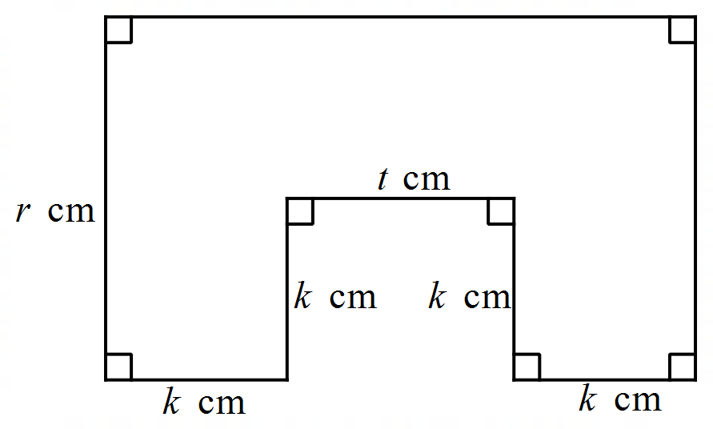

1. Two similar cylindrical containers are such that their capacities are 160 ml and 540 ml respectively. Given that the difference in their heights is 4 cm, calculate the height of the larger cylinder. (3 marks)
2. The figure below show triangle and its image triangle under a transformation described by **M**.



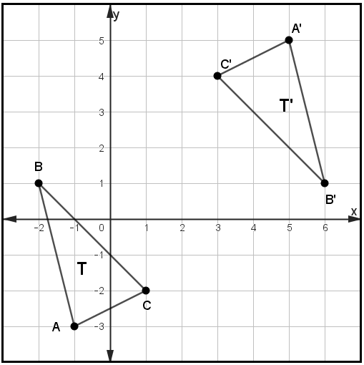

Describe **M** fully (3 marks)

1. Find the number of revolutions made by cylindrical roller of diameter 1.02 m and height 1.3 m. If it rolls over a surface area of 291.72 m2. Use π = (3 marks)



1. Two buses A and B leave the same station. Bus A heads due East while bus B heads due North. The north bound bus travelled 10 km/h faster than the east bound bus. After 5 hours, the two buses are 250 km apart. Calculate the speed of the north bound bus. (4 marks)
2. (a) Find the integral values that satisfy the inequalities below. (3 marks)



(b) Hence show the solution on a number line. (1 mark)

1. If 5 men can construct 2 cottages in 21 days, how many more men, working at the same rate, will be needed to construct 6 cottages in the same period? (3 marks)
2. A trader in Gikomba market sold a bag of potatoes at Ksh. 1 140, giving a discount of 5%. If she made 15% profit from the selling price, find the buying price of the bag of potato, to the nearest shilling. (3 marks)
3. The curved surface area of a cylindrical container is 1980 cm2. If the radius of the container is 21 cm, calculate to one decimal place the capacity of the container. Take . (3 marks)
4. Solve for x in the equation (3 marks)



1. Given that and , without using mathematical tables or calculator, evaluate . (3 marks)
2. Two regular polygons have sides  and . Given that the ratio of the sum of their interior angles is 1: 2, calculate the value of . (3 marks)



1. Solve for  in the equation for . (3 marks)



1. 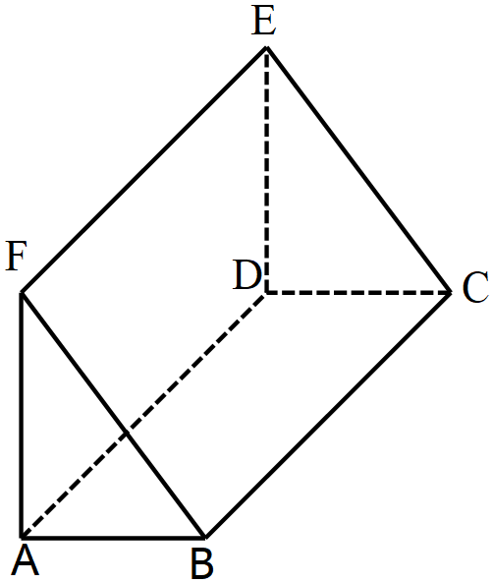The figure below shows a solid ABCDEF. Draw the net of the solid. (2 marks)

**SECTION II – 50 Marks**

*Answer* ***any five*** *questions in this section*

1. Jenipher and Linda decided to start an investment jointly. Jenipher contributed Ksh 500 000 while Linda contributed Ksh 600 000. They agreed that at the end of every year, the profit will be distributed as follows:

* 15% - shared equally between them
* 20% - meeting operational costs of the investment

The rest of the profit shall be shared in the ratio of their contribution.

At the end of the first year, the business realized a profit of Ksh 649 000

1. How much money was set aside for meeting the operational costs of the investment? (2 marks)
2. What was Linda’s share of the profit at the end of the year? (4 marks)
3. Jenipher decided to buy bee hives with her share of the profit, at a cost of Kshs 45 000 per hive. How much money did she remain with after buying the hives? (4 marks)
4. The diagram below represents the cross-section of a petroleum tanker made from a circle centre. AB and CD are equal chords measuring 2.4 m and are 1 m apart on either side of the centre O of the circle. AXB and DYC are segments cut from the circle to form the cross-section. The tanker is 8.5 metres long.

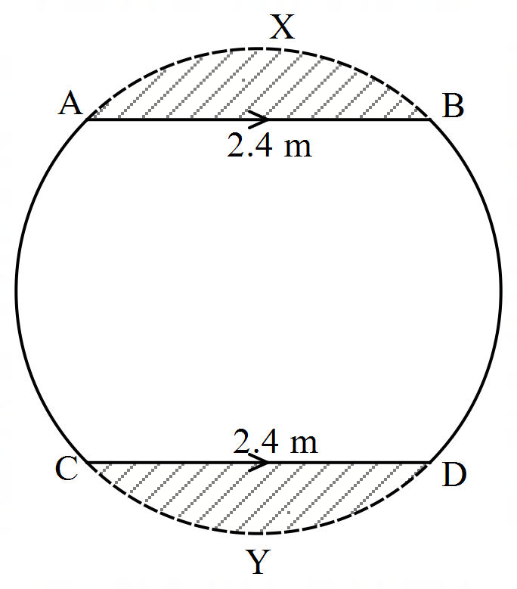

Calculate:

1. the radius of the circle. (1 mark)
2. the area of the cross-section. Use  (6 marks)
3. the capacity of the tank to the nearest one thousand litres. (3 marks)
4. a) Complete the table below for the curve  for . (2 marks)



|  |  |  |  |  |  |  |  |  |
| --- | --- | --- | --- | --- | --- | --- | --- | --- |
|  |  |  |  |  |  |  |  |  |
|  |  |  |  |  |  |  |  |  |

(b) On the grid provided, draw the graph of  for . (3 marks)



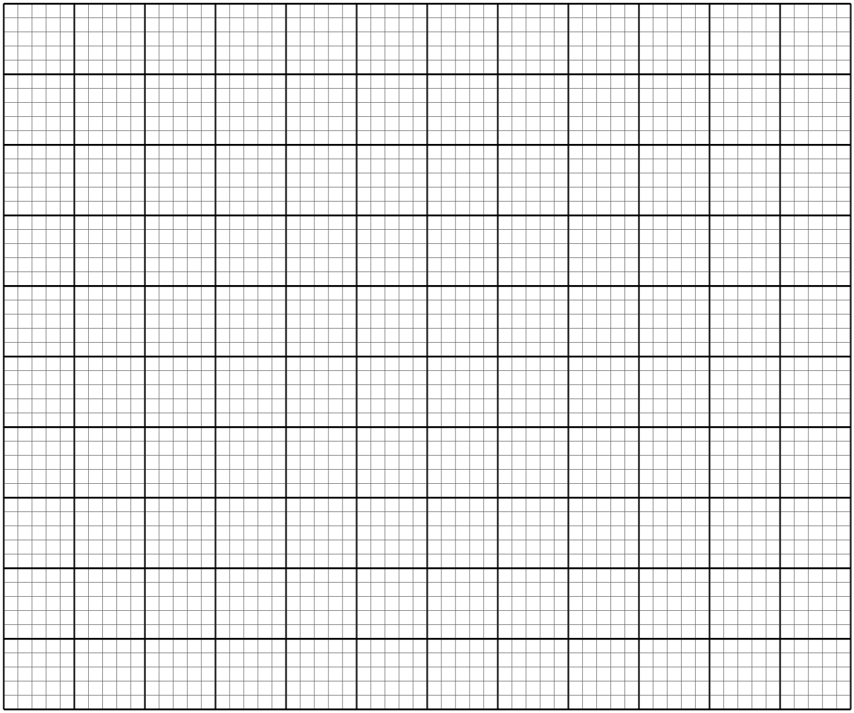

(c) Use the graph in (b) above to find the roots to the following equations:

1. (2 marks)



1. (3 marks)



1. The table below shows marks scored by students in a Mathematics contest

|  |  |  |  |  |  |
| --- | --- | --- | --- | --- | --- |
| Mass (kg) | 5 – 14 | 15 – 29 | 30 – 49 | 50 – 54 | 55 – 62 |
| Number of students | 2 | 12 | 24 | 10 | 12 |

1. Calculate the mean marks (4 marks)
2. Draw a histogram to represent the information above. (3 marks)

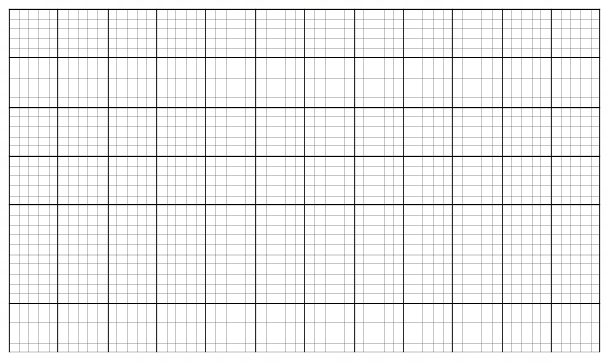

1. On the histogram in (b) above, use a vertical line to show where the median lies. Show your workings. (3 marks)
2. A curve passes through a point P
3. find the value of  (2 marks)
4. Find the equation of a tangent to the curve at P. (3 marks)
5. Determine the:
6. stationary points of the curve (3 marks)
7. nature of each stationary point in (c) (i) above. (2 marks)
8. In a triangle OAB, and . P and Q are points on OA and OB respectively such that and . M is the midpoint of AB



1. Express the following vectors in terms of a and b;
2. (1 mark)



1. (1 mark)



1. Given further that and intersect at R such that and



1. Express in two ways (2 marks)



1. Hence, find the values of and (3 marks)



1. Show that A, R and Q are collinear. (3 marks)

1. Two vertices of a triangle PQR are P and :



* 1. Find the equation of the line PQ in the form , where *m* and *c* are constants. (3 marks)



* 1. Find the equation of the perpendicular bisector of the line PQ in the form , where , and are integers (4 marks)



* 1. Given that PQ is perpendicular to PR at R, and the equation of the line QR is , find the co-ordinates of R. (3 marks)



1. The distance from Garsen to Lamu is 196 km. A matatu left Garsen at 8.30 a.m. for Lamu at an average speed of 54 km/h. After two-thirds of an hour, a van left Lamu for Garsen along the same route at an average speed of 66 km/hr. The two vehicles met in Mpeketoni.
2. Calculate:
3. the time of the day the two vehicles met. (3 marks)
4. the distance between Garsen and Mpeketoni (3 marks)
5. On the same day, a car left Kilifi for Lamu using the same route at an average speed of 90 km/h and caught up with the matatu at the same time as the van.

Find:

1. the time when the car left Kilifi (2 marks)
2. the distance of the car from Lamu at 11a.m. (2 marks)